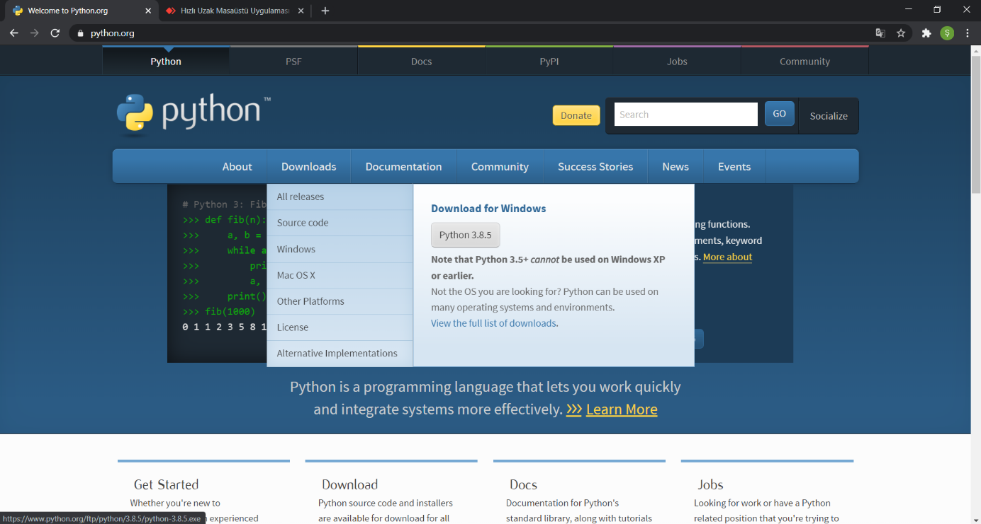

<https://www.python.org/>

Download the file of the programming language from the website.

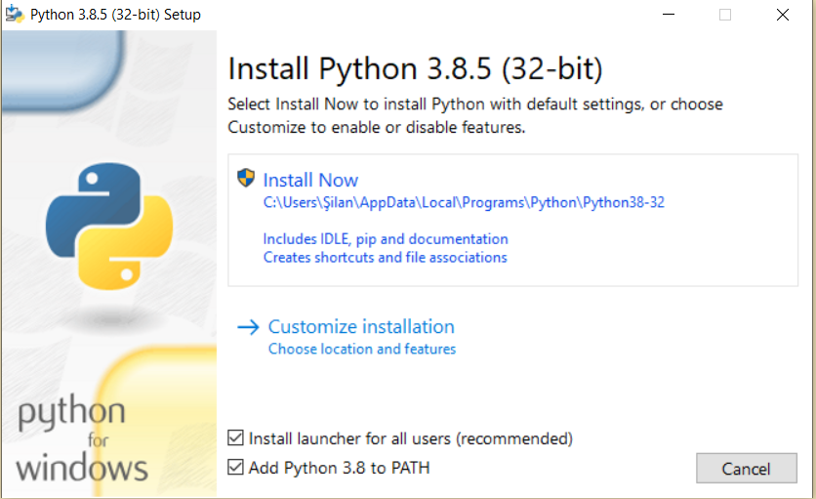

We tick the boxes and click install now. We install and close.

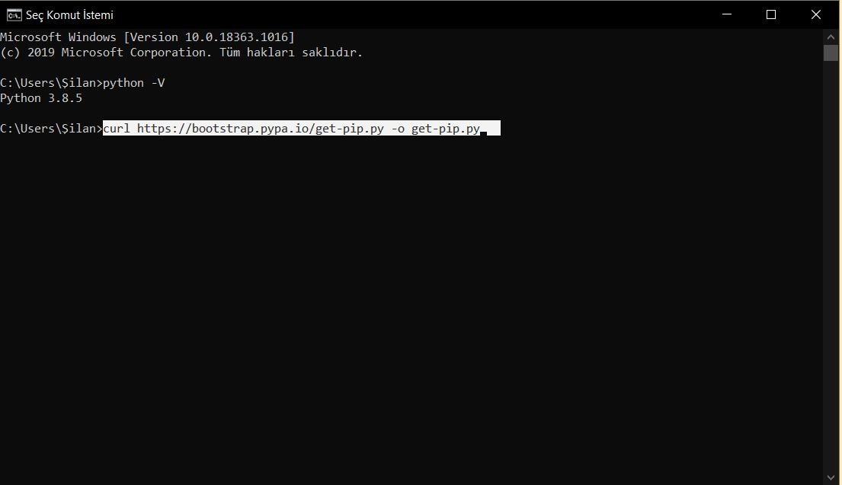

We open cmd, type the command in the picture above and press enter.

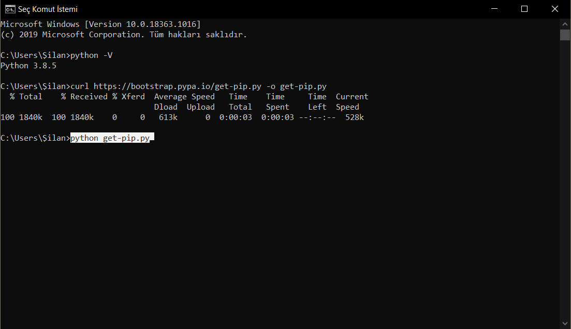

We write the code in the picture again and press enter.

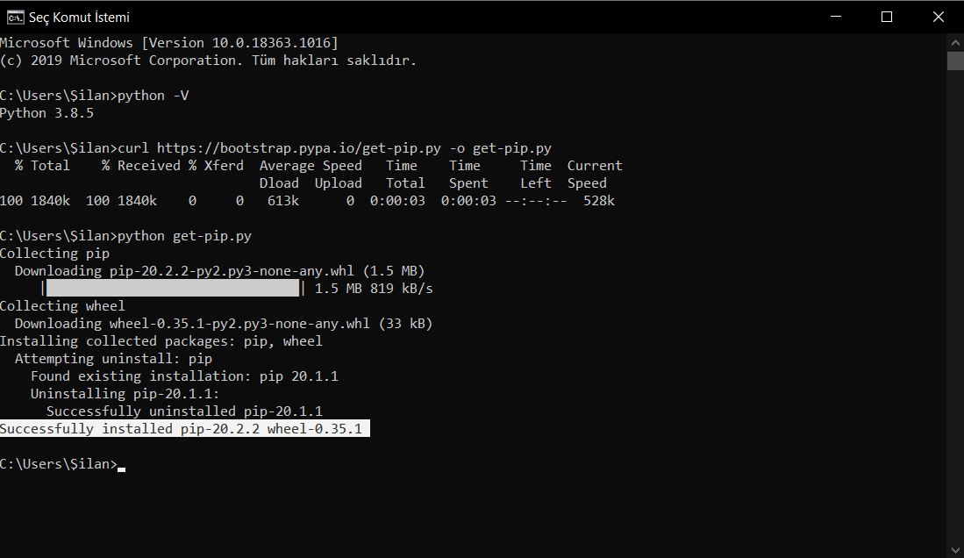

If we get the successful post, we continue.

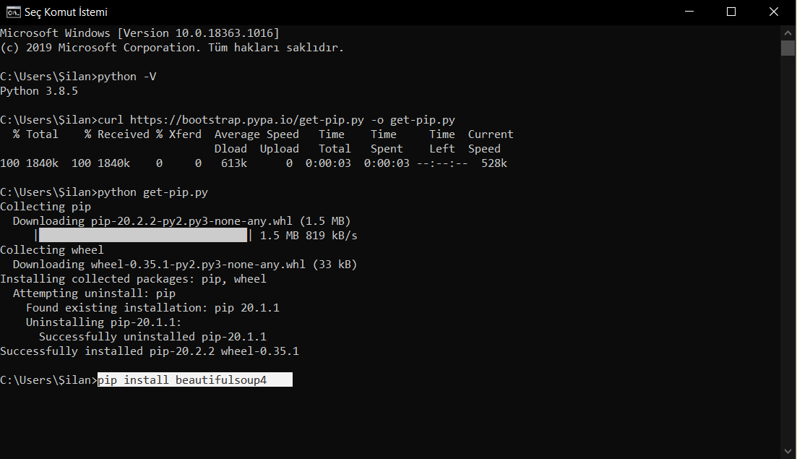

We write the code in the picture again and press enter.

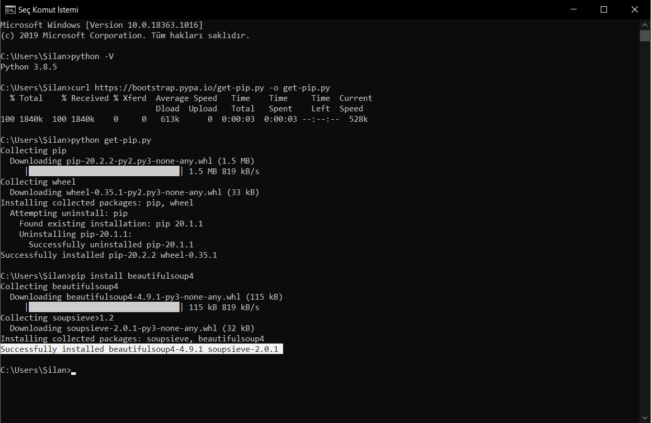

If we get the successful post, we continue.

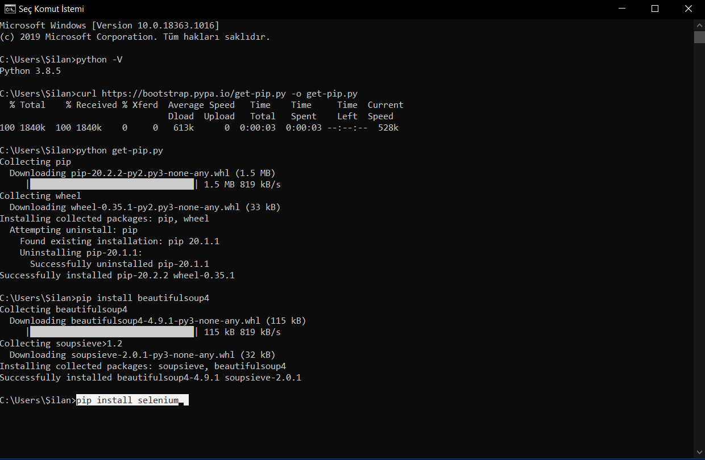

We write the code in the picture again and press enter.

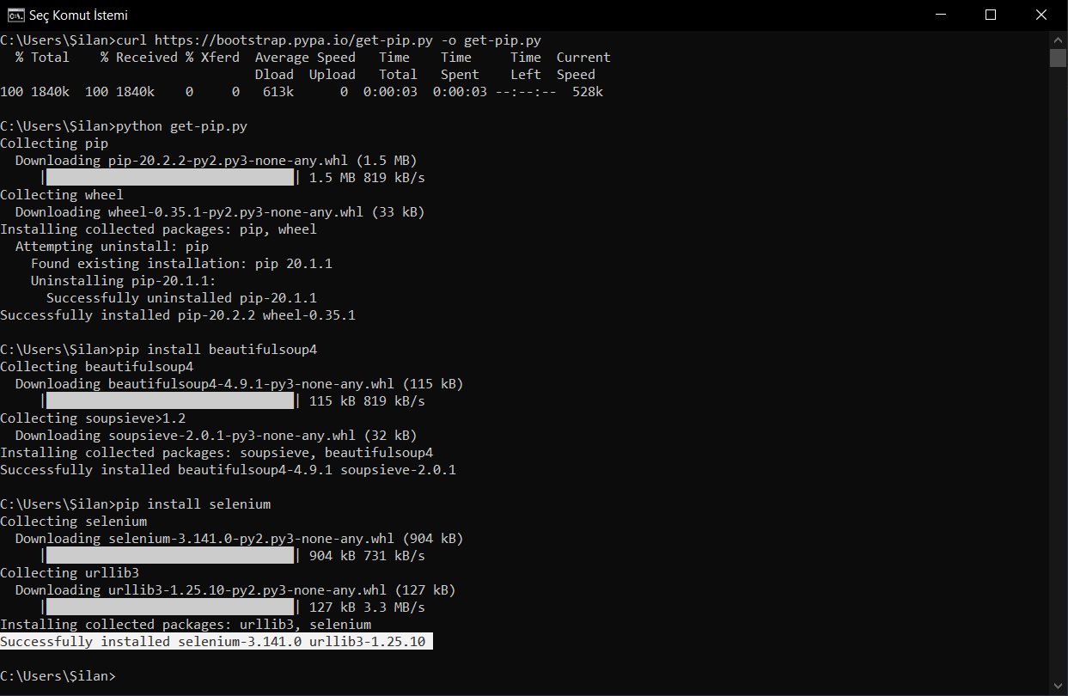

If we get the successful post, we continue.

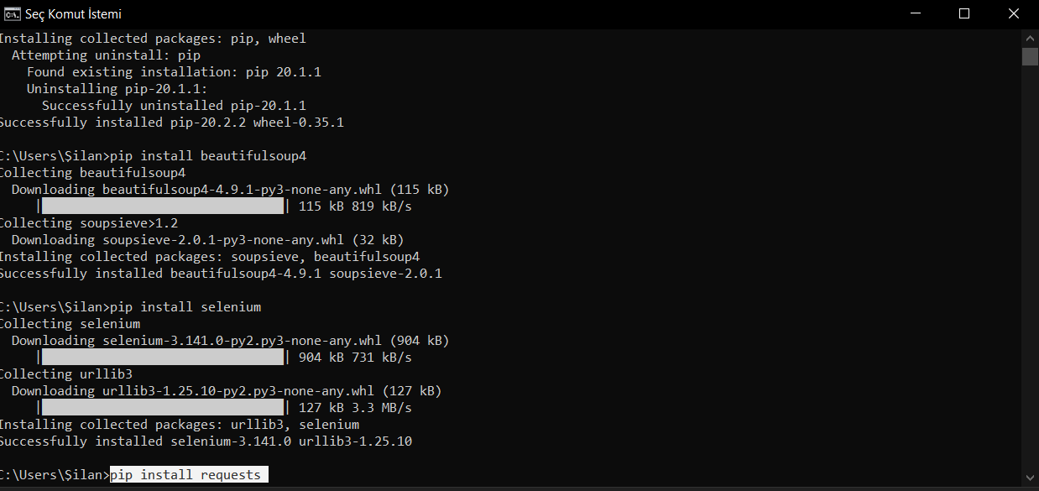

We write the code in the picture again and press enter.

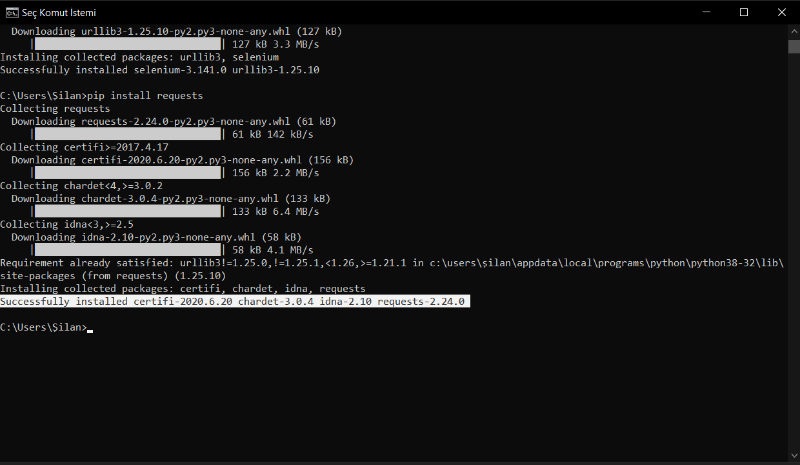

If we get the successful post, we continue.

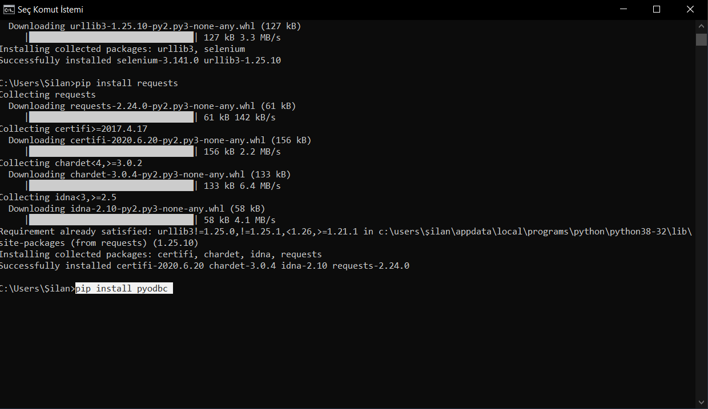

We write the code in the picture again and press enter.

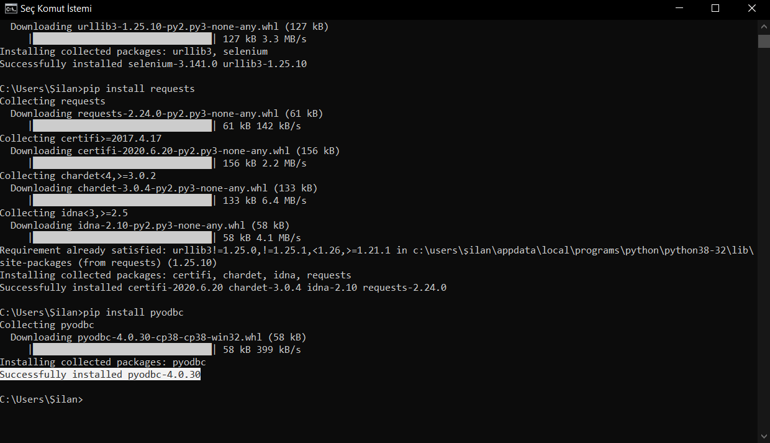

If we get the successful post, we continue. AND close cmd.

<https://www.mozilla.org/tr/firefox/new/>

Download and install the browser.

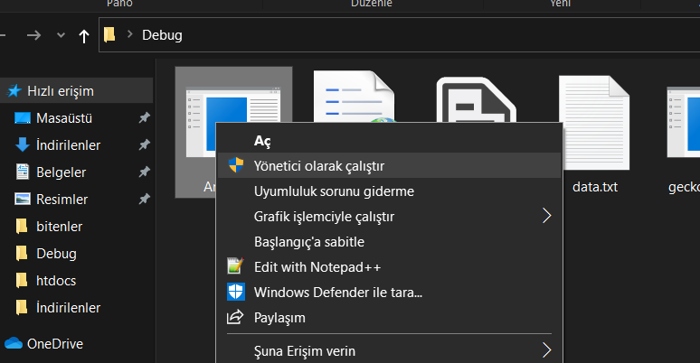

Click Run as administrator

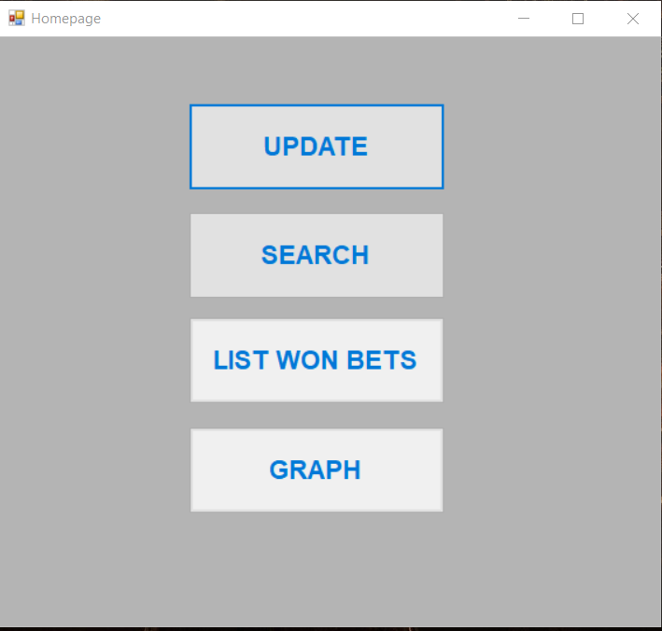

Homepage of the application consists of 4 buttons



Update Button, just click is enough. The command line application will open and this will run our data extraction application. Mozilla firefox browser will open and go to the website. Then the necessary options will be clicked to show all the match programs and the back end of the website will open. The data will be saved in the database and directed to the homepage.

The application does everything, just do nothing unless you get a 404 Not Found error. If you get the error, close the command page and press the update button again.



Search Button, when we click it, it opens the search window to print the lists of the winning odds.

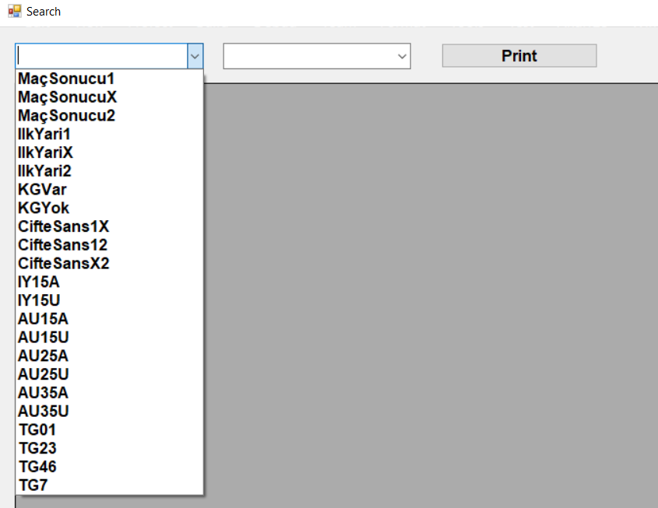

In the search window, we click on the winning odds we want in the first combobox. The options in the first combobox allow you to list the match odds you want.

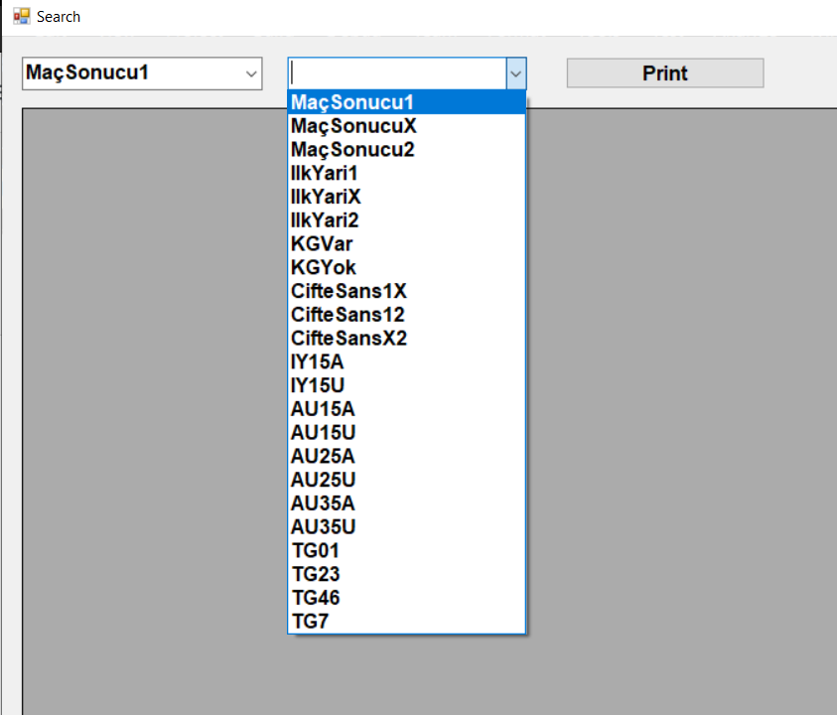

The second combobox also allows us to list the winning odds type or the type of the winning rate together with other types of odds. The odds type in the second combobox may or may not have won.

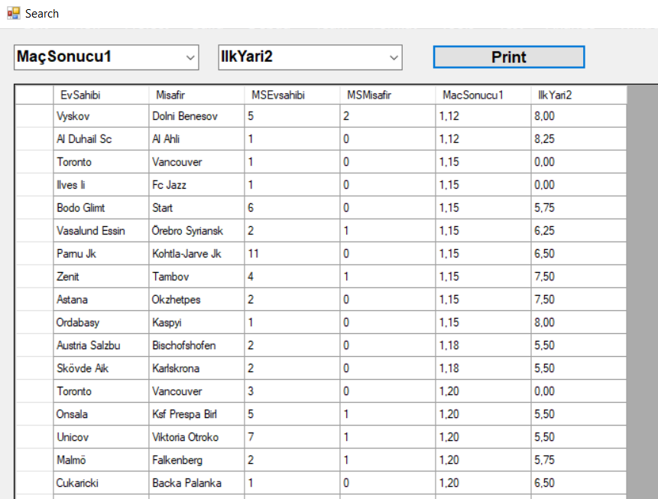

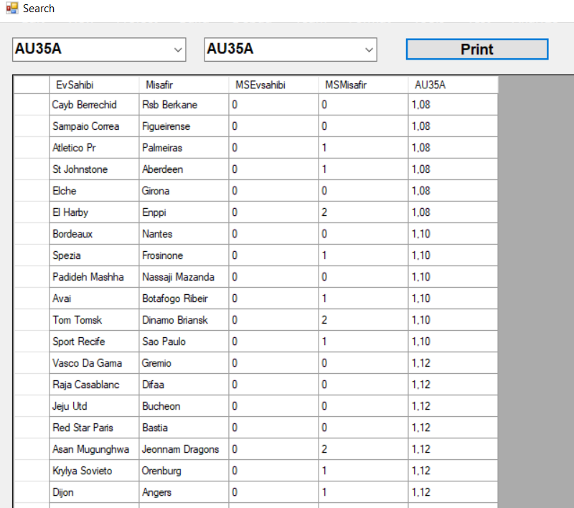



Lıst won bets Button, allows you to print the entire list of winning odds.

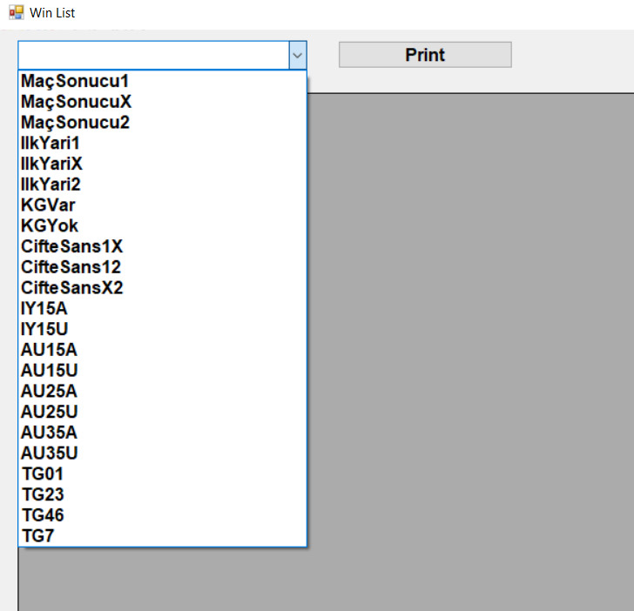

Click on the print button if you want a list of earned odds. All information about the matches of the Winned Odds are listed on the screen.

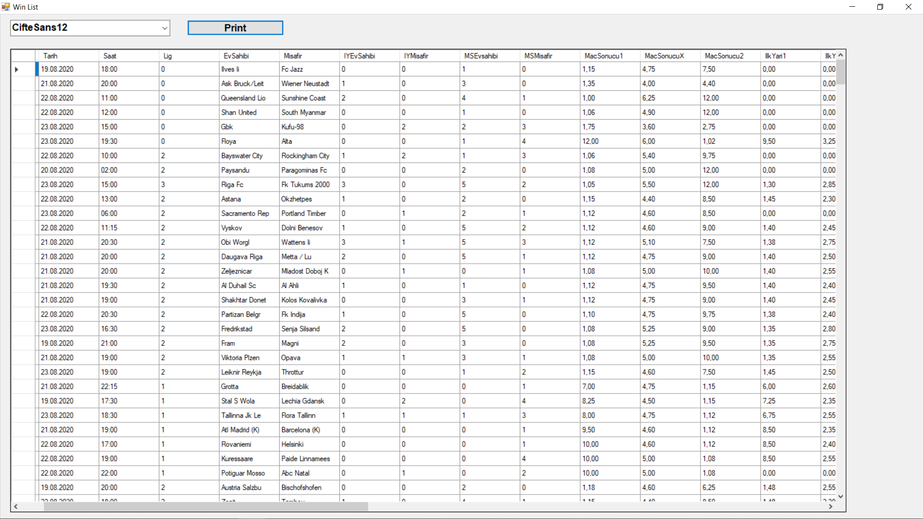

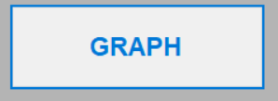

Graph Button, opens a graph window that prints the winning odds as a histogram graph.

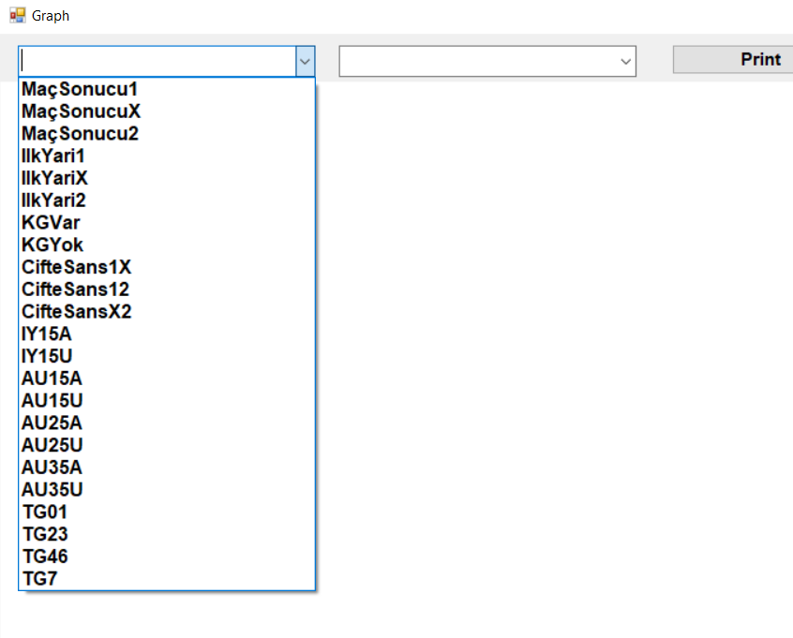

Click on the winning odds you want to see in the first combobox. In the second combobox, if you want to see the winning odds you want to see directly, click on the same odds or the odds you want to see which odds are more in other types of odds and press the screen.

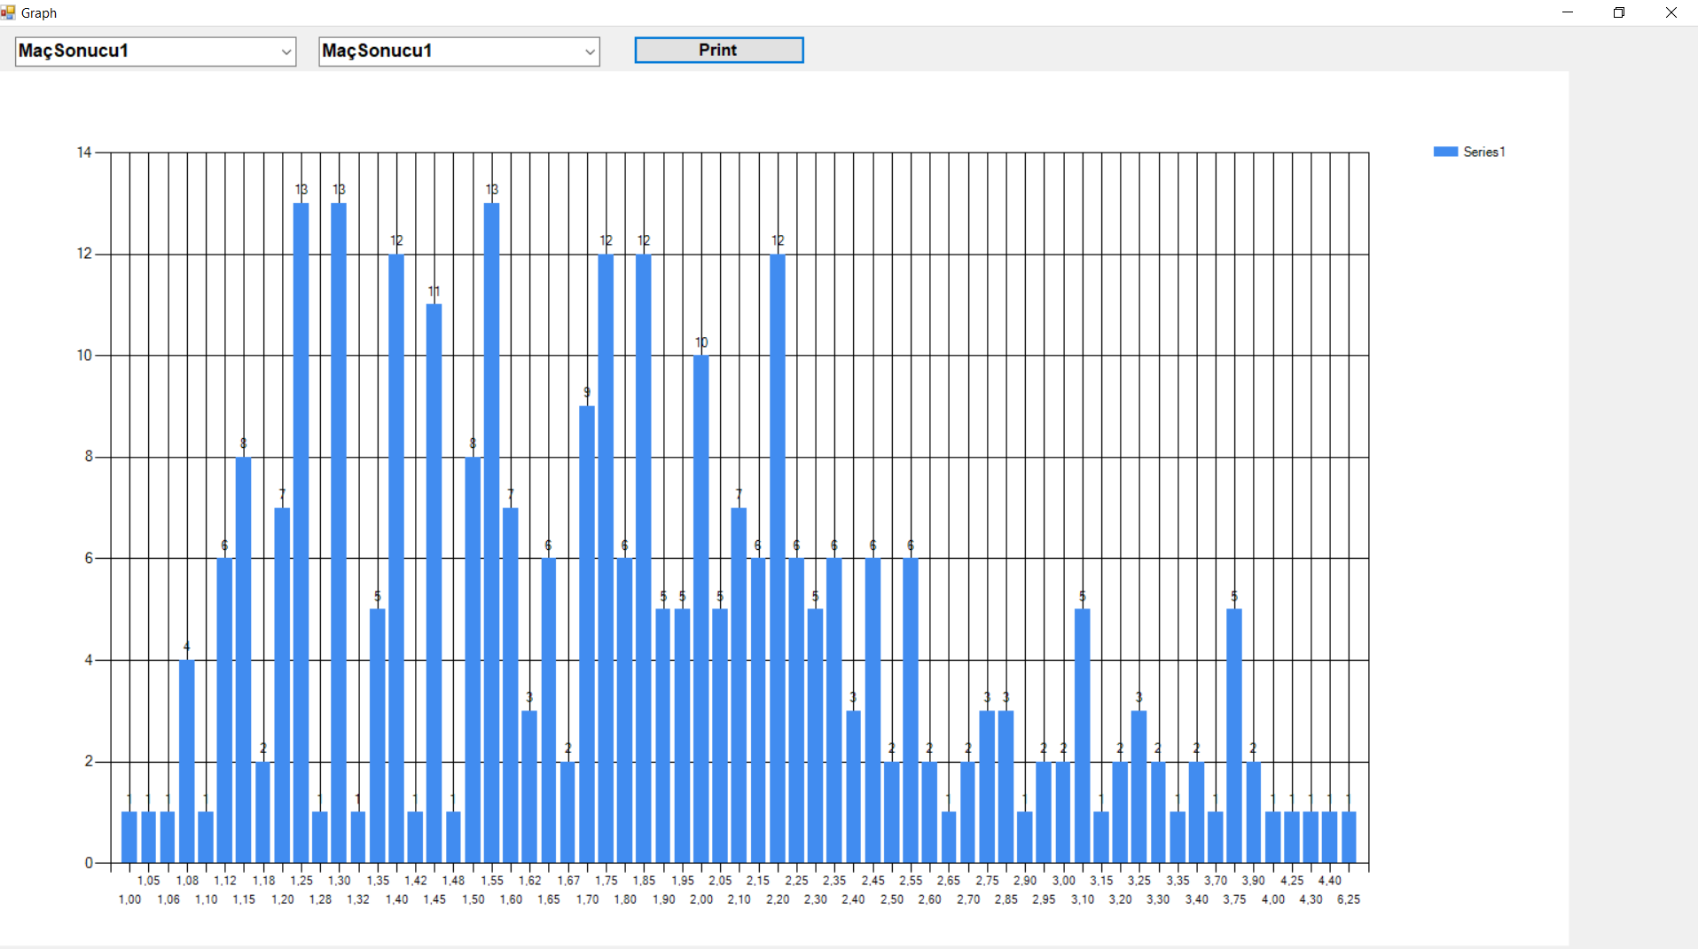

**---------------------------------------------------------------------------------------------------------**

**MAİN.PY**

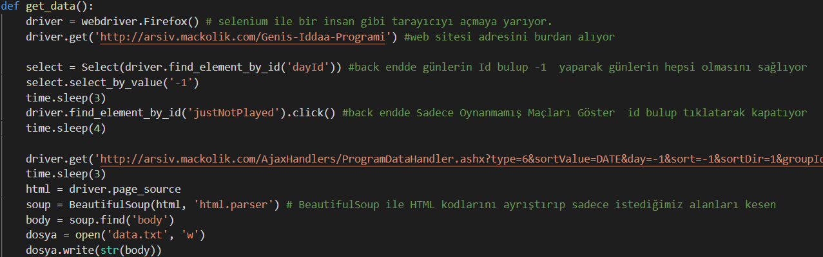

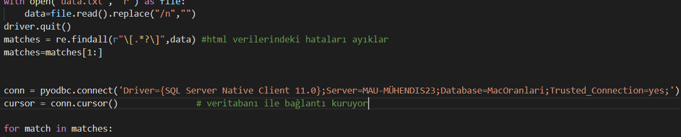

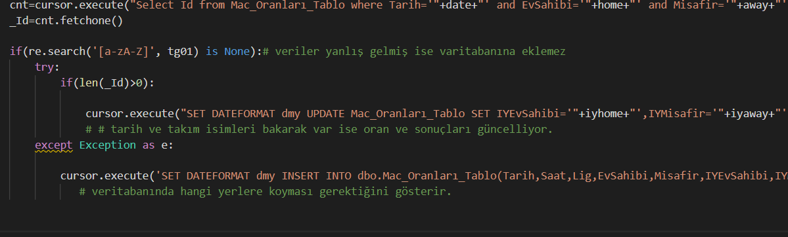

**DATA MANAGER.CS**

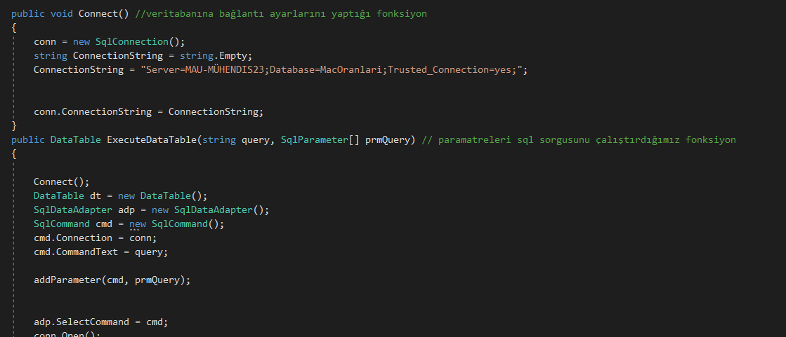

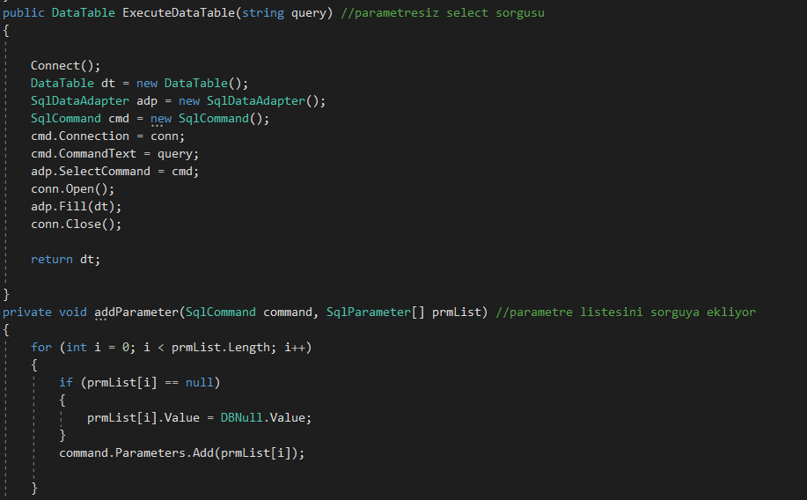

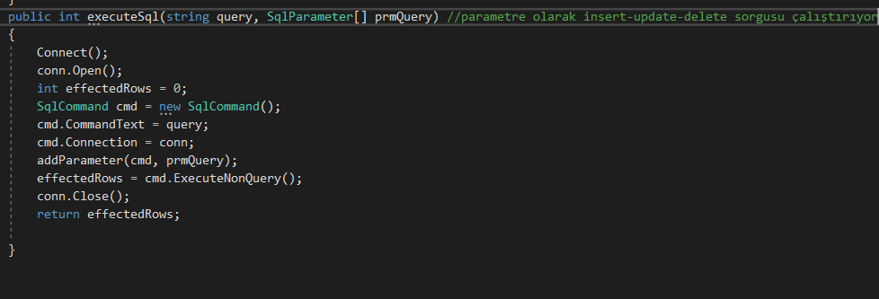

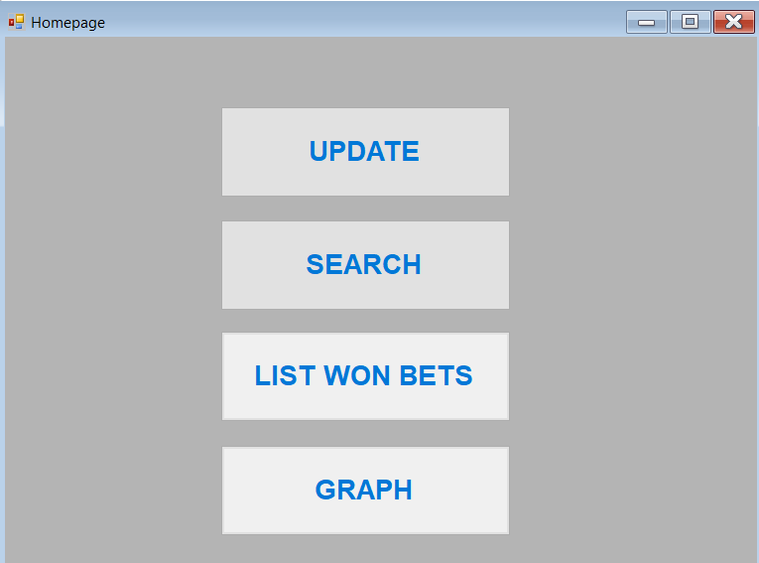

**Form1.cs [Design]**

**Form1 anasayfadır. Sadece diğer pencere gitmek için buttonlar bulunur.**

**Kod olarda butonların tıklanınca diğer pencere gitmesi şartı koşulur.**

**Update butonuda hi.bat komut sistemi açarak update programının çalışmasını sağlar.**

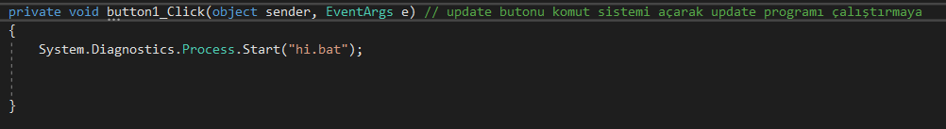

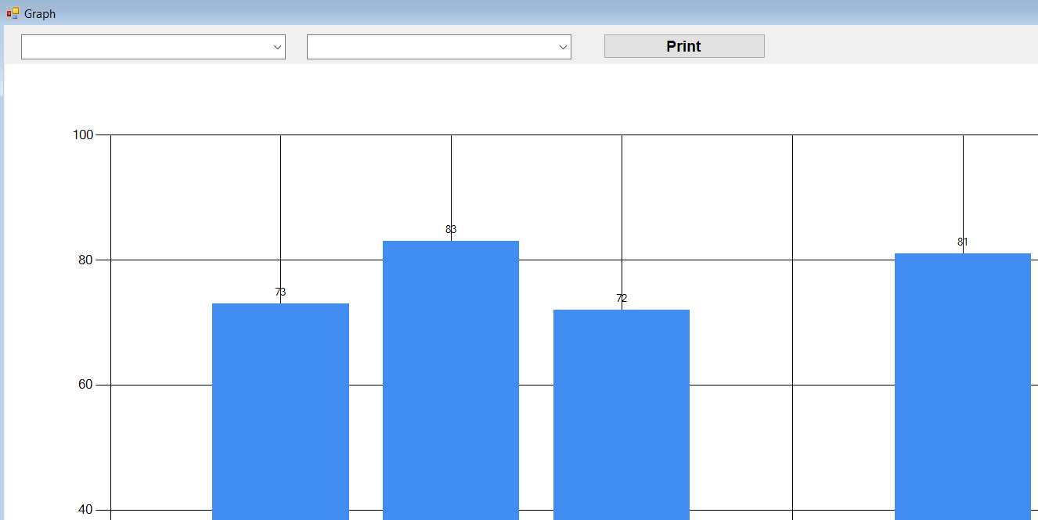

**Form2.cs [Design]**

DataManager dm = new DataManager();

DataTable dt = new DataTable(); **database ile bağlantı sağlamsını sağlayan koddur.**

else if (var1 == "MaçSonucu1" && var2 == "MaçSonucuX") **var1 ilk comobobox var2 de ikinci combobox koşuludur. Seçilene koşula göre gerekli if gider.**

{

dt = dm.ExecuteDataTable("select MacSonucuX, COUNT(MacSonucuX) as T from Mac_Oranları_Tablo where MSEvsahibi > MSMisafir group by MacSonucuX"); **Maç oranları genel tablosunda istenilen sorguya göre sonuçları çekip ekrana bastırır.**

chart1.DataSource = dt;

chart1.Series["Series1"].XValueMember = "MacSonucuX"; **alttaki oranları koddan alan yer.**

chart1.Series["Series1"].YValueMembers = "T**"; toplam değerleri sayısını alan yer**

chart1.Series["Series1"].LabelToolTip = chart1.Series["Series1"].XValueMember;

chart1.ChartAreas[0].AxisX.Interval = 1;

}

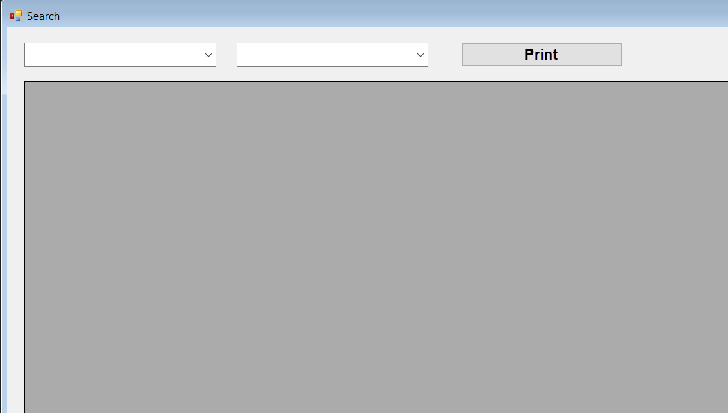

**Form3.cs [Design]**

**İstenilen tutmuş oranlar türleri ekrana bastırır.**

else if (var1 == "MaçSonucu1" && var2 == "MaçSonucuX") **var1 ilk comobobox var2 de ikinci combobox koşuludur. Seçilene koşula göre gerekli if gider.**

{

dataGridView1.DataSource = dm.ExecuteDataTable("select EvSahibi,Misafir,MSEvsahibi,MSMisafir,MacSonucu1,MacSonucuX from Mac_Oranları_Tablo where MSEvsahibi > MSMisafir order by MacSonucu1,MaçSonucuX");

**Maç oranları genel tablosunda istenilen sorguya göre sonuçları çekip ekrana bastırır.**

}

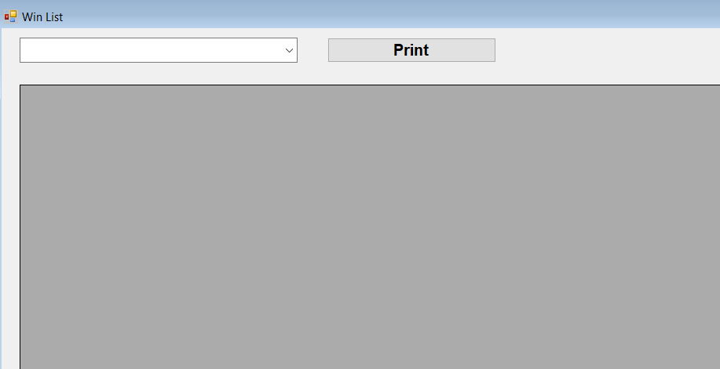

**Form4.cs [Design]**

**Tutmuş oran türünün tüm bilgileri ile bütün maçlarını ekrana bastırır.**

if (var1 == "MaçSonucu1") **tek koşulu vardır tutmuş olan oran türünü girmek.**

{

dataGridView1.DataSource = dm.ExecuteDataTable("select * from Mac_Oranları_Tablo where MSEvsahibi > MSMisafir order by MacSonucu1,MacSonucuX,MacSonucu2"); **istenilen oran türüne göre sorgulamayı yapıp ekrana bastırır.**

}